

**Module Code & Module Title**

**CC6001NI - Advanced Database System Development**

**Assessment Weightage & Type**

**40% Individual Coursework**

**Year and Semester**

**2020-21 Autumn**

**Student Name: Suyogya Luitel**

**Group: C3**

**London Met ID: 19031784**

**College ID: NP01CP4A190035**

**Assignment Due Date: 09th March 2022**

**Assignment Submission Date: 09th March 2022**

I confirm that I understand my coursework needs to be submitted online via Google Classroom under the relevant module page before the deadline for my assignment to be accepted and marked. I am fully aware that late submissions will be treated as non-submission and a mark of zero will be awarded.

# Introduction

This is a report of the coursework involving analysis, design, and implementation of a web-based database application in accordance with the given business case study with the help of tools such as Oracle SQL Developer Data Modeler, Oracle SQL Developer and ASP.NET. According to the presented business scenario, the database should contain information regarding college departments; students, including fee status and attendance; assignments, and their results. The scenario also elaborates that a teacher may be associated wit multiple modules and that a student may become a teacher after graduation.

# Normalization

## Figure 1: Example of Teacher allocation list

|  |  |  |  |  |  |  |
| --- | --- | --- | --- | --- | --- | --- |
| S.N. | Teacher Name | Address | Email | Module  Code | Module Name | Credit Hours |
| 1 | Saul Goodman | 595 Green Lake Road  Black Lake  9115 Lake Street Harrietsfield | Saulthegoodman@ abc.edu.np | CC12 | Data Structure and Algorithm | 30 |
| 2 | Walter White | 696 Madison St. Pierrefonds | [whitywalker@abc.e](mailto:whitywalker@abc.e) du.np | CC12 | Data Structure and Algorithm | 30 |
| 3 | Santana Lopez | 6 Valley View Street Griffintown | Santanalopez@abc. edu.np | CC49 | Engineering Thermodynamic | 60 |
| 4 | Rust Cohle | 89 Coffee Dr. Plaster Rock | [rustycohle@abc.ed](mailto:rustycohle@abc.ed) u.np | SG101 | Software engineer | 30 |
|  |  |  |  | TG405 | Data Analysis | 50 |

Table : Example of Teacher allocation list

Normalization of teacher allocation:

### UNF

Identifying the repeating groups among the given figure fields, we get the following UNF:

Teacher(Teacher_ID, Teacher_Name, {Street_No., Street_Name, State_Name}, Email, {Module_Code, Module_Name, Credit_Hours,})

### 1NF

Separating the repeating groups identified in the UNF above and assigning composite keys, we get the following entities:

Teacher-1 (Teacher_ID, Teacher_Name, Email)

Address-1(Address_ID, Teacher_ID*, Street_No., Street_Name, State_Name)

Module-1(Module_Code, Teacher_ID*, Module_Name, Credit_Hours)

### 2NF

After the repeating groups were separated into different entities and assigned new composite keys, they needed to be checked for partial dependencies.

For Teacher-1:

* No composite keys were present and hence there were no partial dependencies.

Teacher_ID → Teacher_Name, Email

Teacher-2 (Teacher_ID, Teacher_Name, Email)

For Address-1:

* Address_ID key determines Street_No., Street_Name, State_Name
* Address_ID, Teacher_ID* composite key determines nothing
* Teacher_ID* foreign key determines nothing

Address_ID → (Street_No., Street_Name, State_Name)

Address_ID, Teacher_ID* → ()

Teacher_ID → ()

The partial dependencies are separated into new entities as:

Address-2 (Address_ID*, Street_No., Street_Name, State_Name)

Address-Teacher-2 (Address_ID, Teacher_ID*)

For Module-1:

* Module_Code key determines Module_Name, Credit_Hours
* Module_Code, Teacher_ID* composite key determines nothing

Module_Code → (Module_Name, Credit_Hours)

Module_Code, Teacher_ID* → ()

Module -2 (Module_Code, Module_Name, Credit_Hours)

Module-Teacher -2 (Module_Code, Teacher_ID*)

Hence, the results of 2NF are the following entities:

Teacher-2 (Teacher_ID, Teacher_Name, Email)

Address-2 (Address_ID→ Street_No., Street_Name, State_Name)

Address-Teacher-2 (Address_ID, Teacher_ID*)

Module -2 (Module_Code, Module_Name, Credit_Hours)

Module-Teacher -2 (Module_Code, Teacher_ID*)

### 3NF

After checking and removing any partial dependencies, transitive dependencies are required to be checked and removed.

For Teacher-2:

* Teacher_ID determines Teacher_Name and Email
* Teacher_Name determines nothing
* Email determines nothing

There are no transitive dependencies.

Teacher-3 (Teacher_ID, Teacher_Name, Email)

For Address-2:

* Address_ID determines Street_No., Street_Name, State_Name
* Address determines nothing

There are no transitive dependencies.

Address-3 (Address_ID, Street_No., Street_Name, State_Name)

For Address-Teacher 2:

There are no transitive dependencies, the entity contains only a composite primary key.

Address-Teacher-3 (Address_ID, Teacher_ID*)

For Module-Teacher 2:

There are no transitive dependencies, the entity contains only a composite primary key.

Module-Teacher-3 (Module_ID, Teacher_ID*)

For Module-2:

* Module_Code determines Module_Name, Credit_Hours
* Module_Name determines nothing
* Credit_Hours determines nothing

Module_Code → (Module_Name, Credit_Hours)

The transitive dependencies are separated into entities as follows:

Module-3 → (Module_Code, Module_Name, Credit_Hours)

Hence, the results of 3NF are the following entities:

Teacher-3 (Teacher_ID, Teacher_Name, Email)

Address-3 (Address_ID, Address)

Address-Teacher-3 (Address_ID, Teacher_ID*)

Module-3 (Module_Code, Module_Name, Credit_Hours)

Module-Teacher-3 (Module_ID, Teacher_ID*)

### Final entities from figure 1

After normalizing figure 1 up to third normal form, the following entities are obtained:

Teacher (Teacher_ID, Teacher_Name, Email)

Address (Address_ID, Street_No., Street_Name, State_Name)

Address-Teacher (Address_ID, Teacher_ID*)

Module (Module_Code, Module_Name, Credit_Hours)

Module-Teacher (Module_ID, Teacher_ID*)

## Fig 2: Example of Assignment and Examination Results

Student ID: 149893

Student Name: Mr. William Ishee

Student Address: 2508 Shinn Street New York

|  |  |  |  |  |
| --- | --- | --- | --- | --- |
| Module  Code | Module Name | Assignment Type | Grade | Status |
| CC12 | Data Structure and Algorithm | Coursework | A | Pass |
| CC49 | Engineering Thermodynamic | Coursework | B | Pass |
| CC49 | Engineering Thermodynamic | Written Exam | F | Fail |
| SG101 | Software engineer | Individual  Assignment | B+ | Pass |
| SG101 | Software engineer | Group Assignment | B | Pass |
| SG101 | Software engineer | Unseen Examination | A | Pass |

While the given example is very informative, it does not contain information regarding semester and semester fees. Additionally, student attendance as well as student fee payment information also seems missing. Hence, additional fields "semester", "semester fees", "student attendance", and "fee status" seem to be a necessary addition.

Assumptions:

* Attendance of students is recorded for each semester in percentage value at the end of each semester.
* Each semester has a fee associated with it.
* Semester fees of the students are common regardless of the modules they study. This implies that students A and B studying module sets C and D have the same semester fees if they both are in semester E.
* When a student pays semester fees, their fee status is updated to paid.
* A student cannot have multiple addresses.

### UNF

Adding the above-mentioned fields to the given Figure 2 fields, and identifying the repeating groups among them, we get the following UNF:

Student (Student_ID, Sudent_Name, Street_No., Street_Name, State_Name, {Module_Code, Module_Name {Assignment_Type, Grade, Status}})

### 1NF

Separating the repeating groups identified in the UNF above and assigning composite keys, we get the following entities:

Student-1(Student_ID, Student_Name, Street_No., Street_Name, State_Name)

Module-1 (Module_Code, Student_ID*, Module_Name)

Assignment-1(Assignment_ID, Student_ID*, Module_Code*, Assignment_Type, Grade, Status)

### 2NF

After the repeating groups were separated into different entities and assigned new composite keys, they needed to be checked for partial dependencies.

For Student-1:

* No composite keys were present and hence there were no partial dependencies.

Student_ID → (Student_Name, Street_No., Street_Name, State_Name)

Student-2 (Student_ID, Student_Name, Street_No., Street_Name, State_Name)

For Module-1:

* Module_Code key determines Module_Name
* Module_Code, Student_ID* composite key determines nothing
* Student _ID* foreign key determines nothing

Student_ID, Module_Code → ()

Student_ID → ()

Module_Code → (Module_Name)

Module-Student-2 (Student_ID*, Module_Code*)

Module-2(Module_Code, Module_Name)

For Assignment-1:

* Assignment_ID key determines Assigment_Type
* Assignment_ID, Student_ID*, Module_Code* composite key determines Grade, Status
* Student _ID* foreign key determines nothing
* Module _Code* foreign key determines nothing

Assignment_ID → (Assignment_Type)

Assignment_ID, Student_ID, Module_Code → (Grade, Status)

Student_ID → ()

Module_Code → ()

The partial dependencies are separated into new entities as:

Assignment-2 (Assignment_ID, Assignment_Type)

Student-Assignment-2(Assignment_ID*, Student_ID*, Module_Code*, Grade, Status)

Hence, the results of 2NF are the following entities:

Student-2 (Student_ID, Student_Name, Street_No., Street_Name, State_Name)

Module-Student-2 (Student_ID*, Module_Code*)

Module-2(Module_Code, Module_Name)

Assignment-2 (Assignment_ID, Assignment_Type)

Student-Assignment-2(Assignment_ID*, Student_ID*, Module_Code*, Grade, Status)

### 3NF

After checking and removing any partial dependencies, transitive dependencies are required to be checked and removed.

For Student-2 :

* Student_ID determines Student_Name, Street_No., Street_Name, State_Name Student_Name determines nothing
* Student_Address determines nothing

Student_ID → (Student_Name, Street_No., Street_Name, State_Name)

There are no transitive dependencies.

Student-3 (Student_ID, Student_Name, Street_No., Street_Name, State_Name)

For Module-Student-2:

There are no transitive dependencies, the entity contains only a composite primary key.

Module-Student-3 (Student_ID*, Module_Code*)

For Module-2:

* Module_Code determines Module_Name
* Module_Name determines nothing

There are no transitive dependencies.

Module-3(Module_Code, Module_Name)

For Assignment-2:

* Assignment_ID determines Assigment_Type
* Assignment_Type determines nothing
* Module_Name determines nothing

There are no transitive dependencies.

Assignment-3 (Assignment_ID, Assignment_Type)

For Student-Assignment-2:

* Assignment_ID, Student_ID, Module_Code composite key determines Grade
* Grade determines Status
* Status determines nothing

Assignment_ID*, Student_ID*, Module_Code* → Grade

Grade → Status

The transitive dependencies are separated as:

Student-Assignment-3 (Assignment_ID*, Student_ID*, Module_Code*, Grade_ID*)

Grade-3 (Grade_ID, Grade, Status)

Hence, the results of 3NF are the following entities :

Student-3 (Student_ID, Student_Name, Street_No., Street_Name, State_Name)

Module-Student-3 (Student_ID*, Module_Code*)

Module-3(Module_Code, Module_Name)

Assignment-3 (Assignment_ID, Assignment_Type)

Student-Assignment-3 (Assignment_ID*, Student_ID*, Module_Code*, Grade_ID*)

Grade-3 (Grade_ID, Grade, Status)

### Final entities from figure 2

After normalizing figure 2 up to third normal form, the following entities are obtained:

Student (Student_ID, Student_Name, Street_No., Street_Name, State_Name)

Module-Student (Student_ID*, Module_Code*)

Module(Module_Code, Module_Name)

Assignment (Assignment_ID, Assignment_Type)

Student-Assignment (Assignment_ID*, Student_ID*, Module_Code*, Grade_ID*)

Grade (Grade_ID, Grade, Status)

## Integration

Assumptions:

* A teacher may have multiple addresses but a student can only have one address recorded.
* Grade is evaluated in a single alphabet optionally followed by a sign (Ex : A, A+).
* College has additional departments for managing examinations, assessments, results; as well as fees.
* The students also have their attendance recorded as a percentage at the end of each semester before conducting examinations.
* Each semester, students are required to pay the allocated semester fees.
* When a student pays semester fees, their fee status is updated to paid.
* In order to store the fees paid amount, the fee amount is redundantly added to the student_fees table so it always remains the same even if the semester fees change over time.
* Assignments and their results, attendance, and fees are managed by departments
* A student is can study any three module they want.
* A teacher can teach one or multiple modules.
* Different semesters may have different fees.
* Student assignments for each module are recorded only after their grades have been evaluated.

While the given example tables are very informative, they do not contain information regarding college departments. They also do not contain information regarding semester, semester fees, attendance, and fee status. Thus, the entities "Department", and "Semester", "Student_Fees" and "Student_Attendance" are added to the result of normalizing figures one and two with appropriate relations to existing entities.

Teacher (Teacher_ID, Teacher_Name, Email)

Address (Address_ID, Street_No., Street_Name, State_Name)

Address-Teacher (Address_ID, Teacher_ID*)

Module (Module_Code, Module_Name, Credit_Hours)

Module-Teacher (Module_ID*, Teacher_ID*)

Student (Student_ID, Student_Name, Street_No., Street_Name, State_Name)

Module-Student (Student_ID*, Module_Code*)

Department (Department_ID, Department_Name)

Assignment (Assignment_ID, Assignment_Type, Department_ID*)

Student-Assignment (Assignment_ID*, Student_ID*, Module_Code*, Grade_ID*)

Grade (Grade_ID, Grade, Status)

Semester (Semester_ID, Semester, Semester_Fees)

Student_Fees (Semester_ID*, Student_ID*, Fee_Status, Department_ID*, Fee_Amount)

Student_Attendance (Semester_ID*, Student_ID*, Attendance_Percentage)

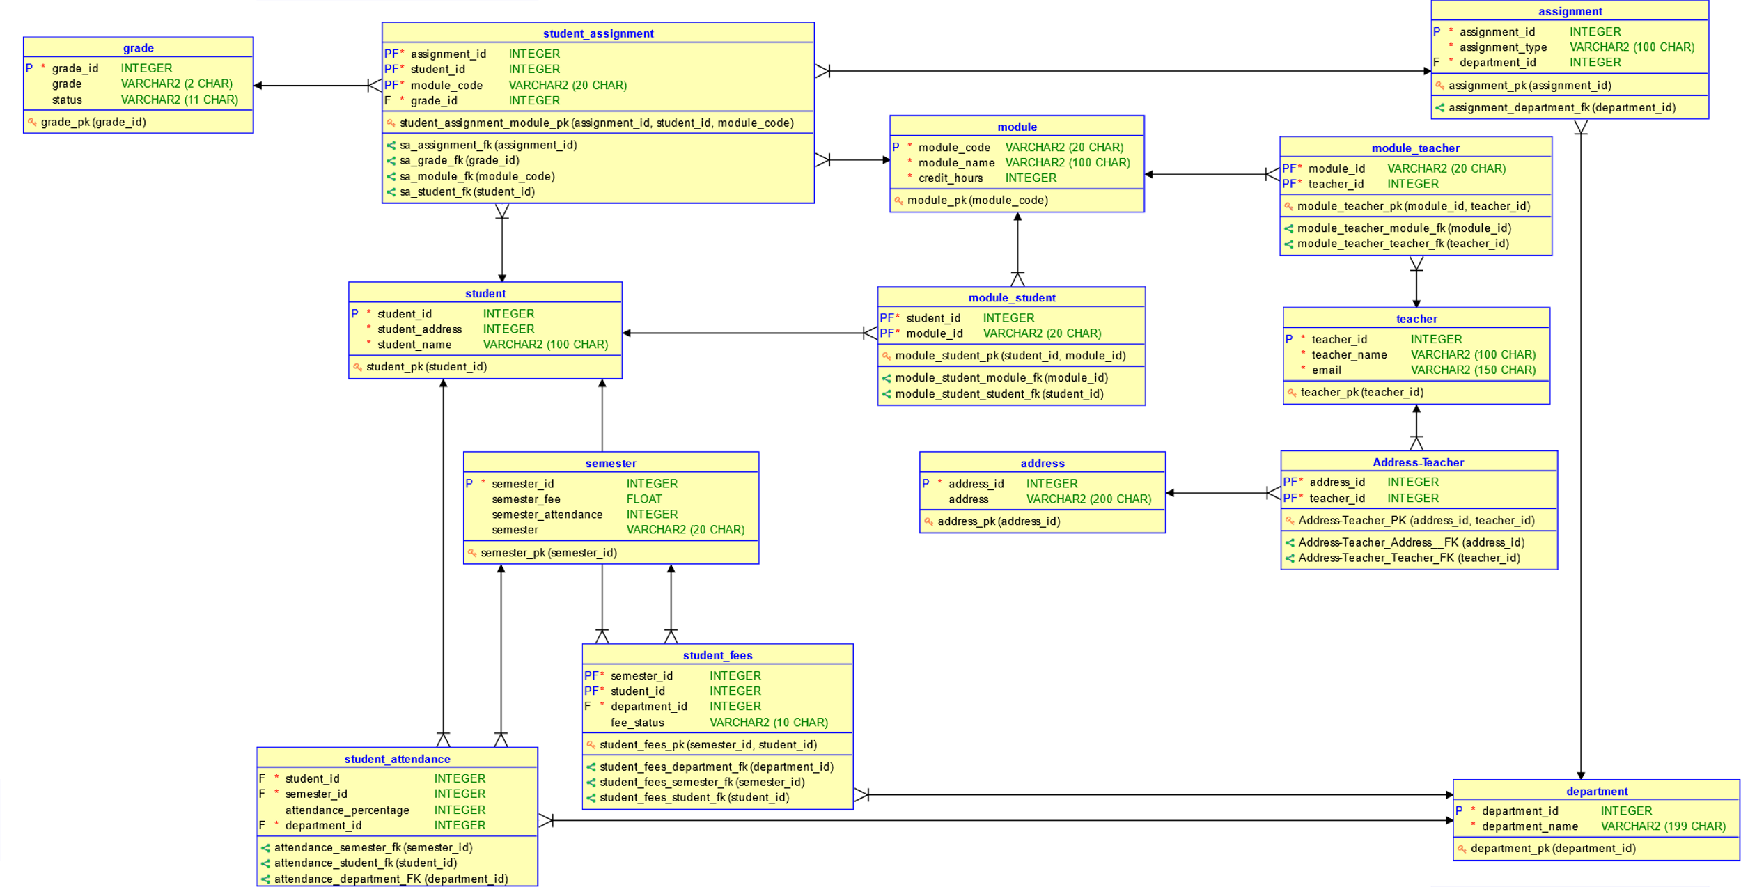

Figure : Final ERD After Integration

CHANGE PICTURE, REMOVE SEMESTER_ATTENDANCE